# Goals

How might we create a better listening experience

How might we make it easier to listen to a trustworthy news source in the era of fake news

How might we grow and engage a more diverse audience: increase audience size, diversity, and loyalty

How might we expand our audience to better reflect the demographic composition of Chicago

* 40% of Chicagoland is Black/Latinx as compared to 31% of WBEZ listeners, similarly 11% of Chicagoland is 18 in this age group24 whereas only 7% of WBEZ listeners are

# Personas

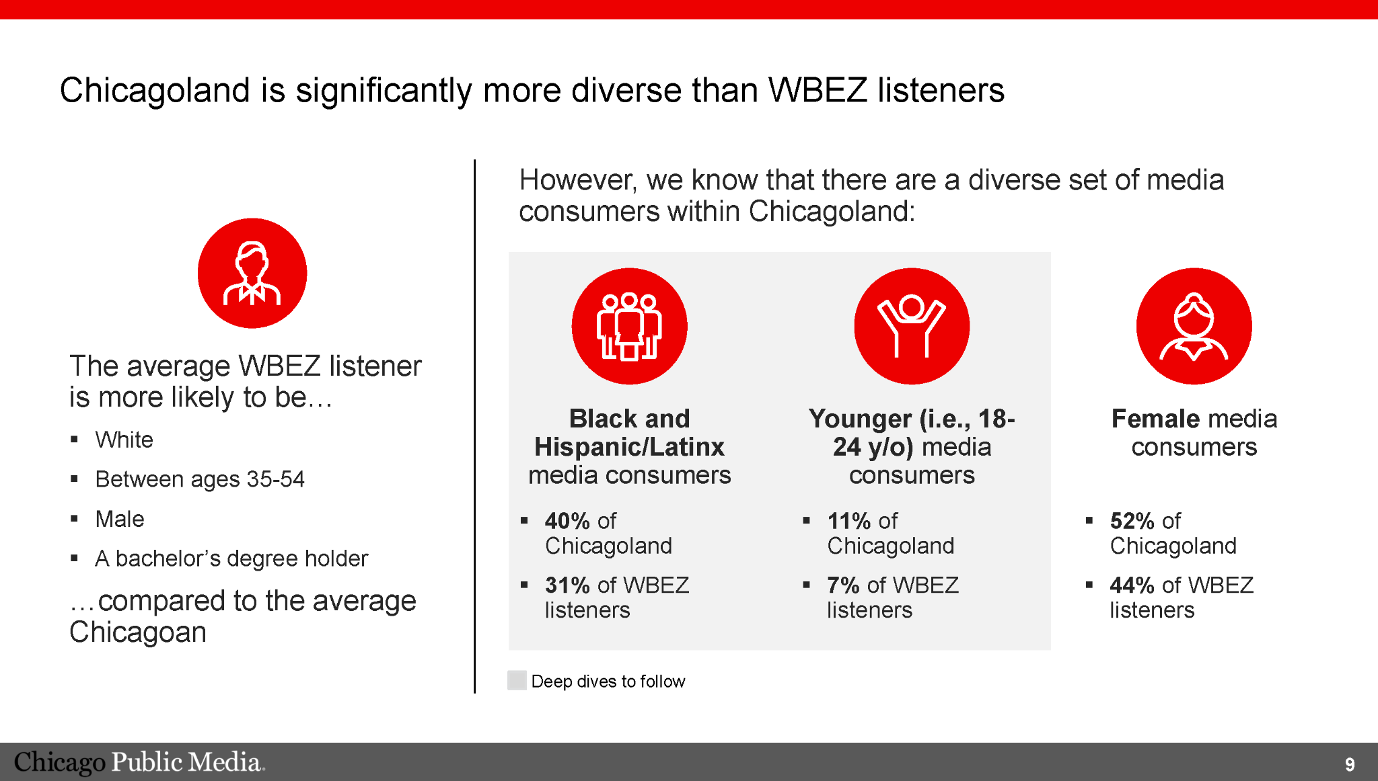

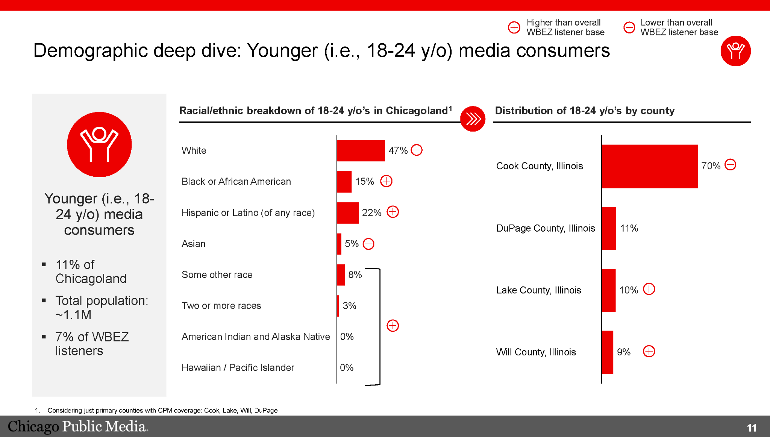

# Project timeline

|  | **Ash** | **Box** | **Cockle** | **Date** | **Elder** | **Flag** | **Grace** | **Hawthorn** | **Ivy** | **Kecksies** | **Ling** | **Mace** | **Narcissus** |
| --- | --- | --- | --- | --- | --- | --- | --- | --- | --- | --- | --- | --- | --- |
| **Start Date** | 7/5 | 7/21 | 8/4 | 8/18 | 9/1 | 9/15 | 9/29 | 10/13 | 10/27 | 11/10 | 11/24 | 12/8 | 12/22 |
| **End Date** | 7/20 | 8/3 | 8/17 | 8/31 | 9/14 | 9/28 | 10/12 | 10/26 | 11/9 | 11/23 | 12/7 | 12/21 | 1/4 |
| **Notes** |  | Launch Email Capture Wall | Release Donation Form Updates | *Offer Sustainer-only Premiums (will be available during this SB release)*  *Tentative: Frequency work goes to SB staging on 8/23* |  | **Pledge: 9/9 - 9/15**  **Release Donation Form Updates**  **SB: Production Release 9/16** |  | Submit WBEZ App target: 10/26 | Release WBEZ App 11/1 |  |  |  |  |
|  |  | Wireframe and Spec WBEZ App 9.0 | Develop WBEZ Mobile App v9.0 | | | | | |  | Wireframe and Spec WBEZ App 9.1 | Develop WBEZ Mobile App v9.1 ->  w/ Push Notifications | | |

# 

# Feature prioritization

## Listening experience: Audio player

Users are able to listen to WBEZ 91.5 live radio streams and on-demand content. To improve the experience the app’s MVP should include

* Apple CarPlay

## Content experience: Browse Homepage

Social media and network news are the most frequently used platforms for news. From this my team determined that the homepage should be a browse page.